**DAILY ONLINE ACTIVITIES SUMMARY**

|  |  |  |  |  |  |  |  |  |
| --- | --- | --- | --- | --- | --- | --- | --- | --- |
| **Date:** | 05/06/2020 | | | | | **Name:** | CHANDANA S | |
| **Sem & Sec** | 4th SEM ‘A’ SEC | | | | | **USN:** | 4AL18CS016 | |
| **Online Test Summary** | | | | | | | | |
| **Subject** | | N/A | | | | | | |
| **Max. Marks** | | N/A | | **Score** | | | N/A | |
| **Certification Course Summary** | | | | | | | | |
| **Course** | Introduction to Neural Networks and Deep Learning | | | | | | | |
| **Certificate Provider** | | | Great Learning | | **Duration** | | | 3 Hours |
| **Coding Challenges** | | | | | | | | |
| **Problem Statement:**1. write a java program to read three integer values from the keyboard  and find the sum of the values.  2.Write a C++ program to find the missing number in array. | | | | | | | | |
| **Status:** Completed | | | | | | | | |
| **Uploaded the report in Github** | | | | | YES | | | |
| **If yes Repository name** | | | | | <https://github.com/chandushivalingareddy/lockdown-coding> | | | |
| **Uploaded the report in slack** | | | | | YES | | | |

**Online Test Details:** N/A

**Certification Course Details:**

**Name of the course**: Introduction to Neural Networks and Deep Learning

**Certificate Provider**: Great Learning

Today I went through the course that explained about Neural Networks deconstructed for SL and Introduction to TensorFlow and Keras.

**Snapshot:**

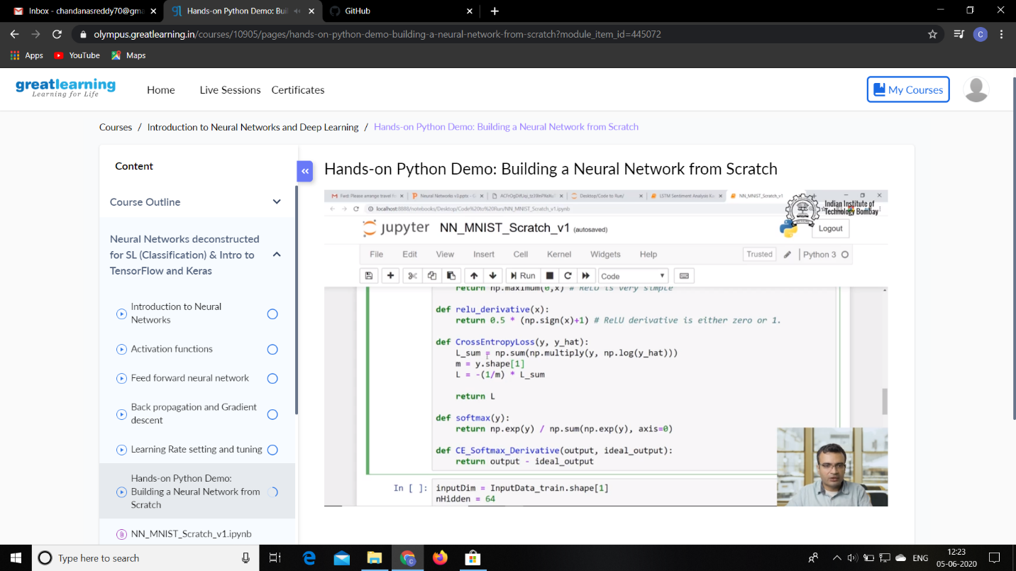

**Online Coding Details:**

Problem 1: write a java program to read three integer values from the keyboard and find the sum of the values.

Output: Process being scheduled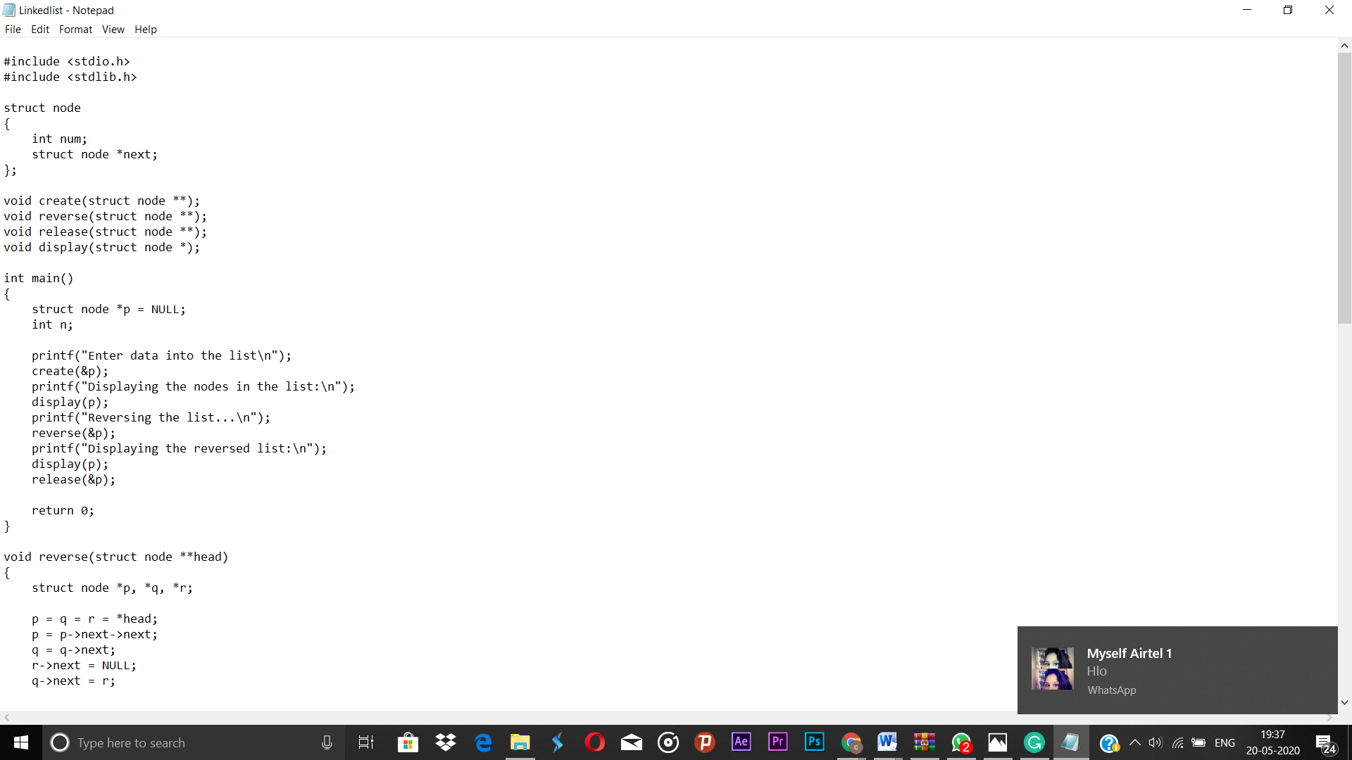Top of Form

Bottom of Form

**Snapshot:**

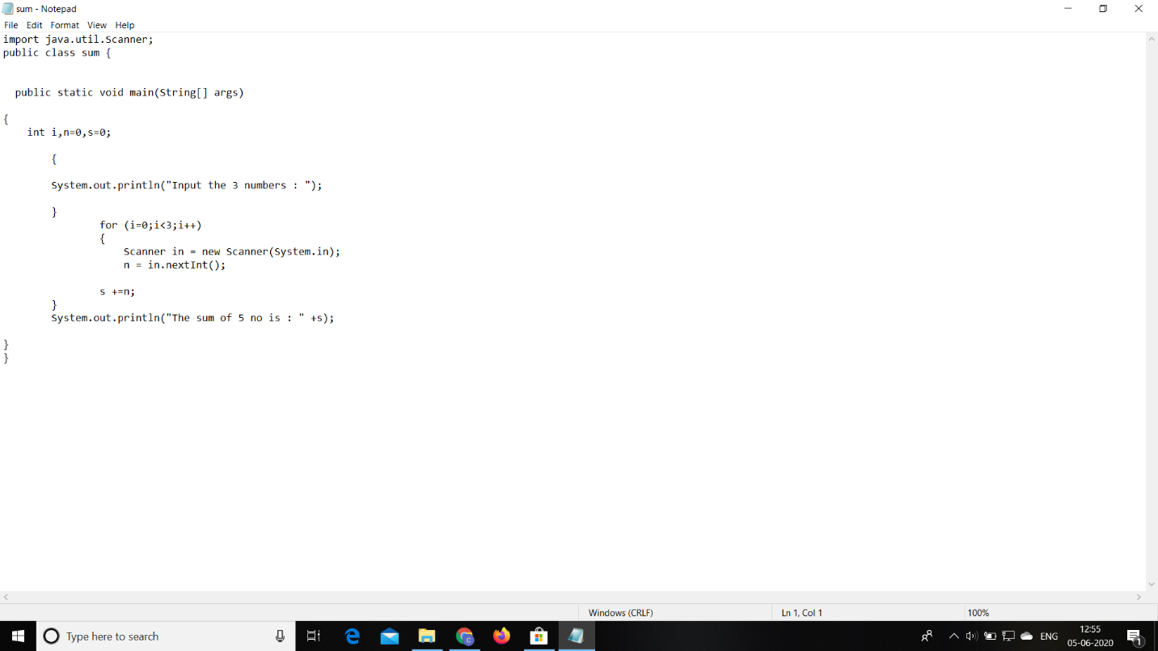

Problem 2: Write a C++ program to find the missing number in array.

**Snapshot:**

